Black vs white box testing

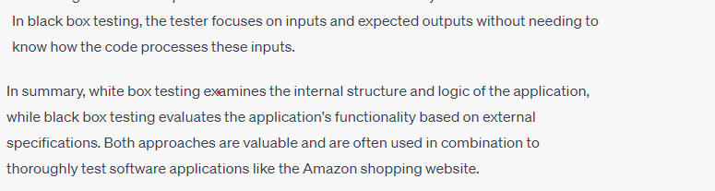

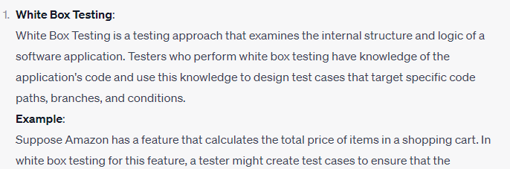

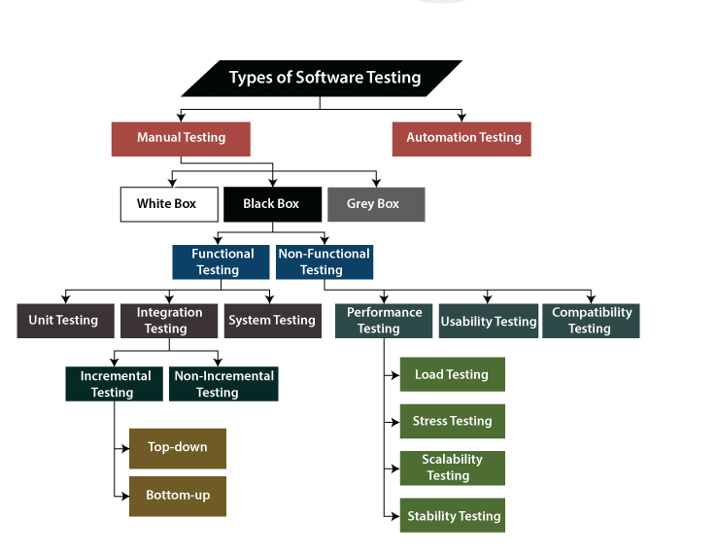

Regression Testing

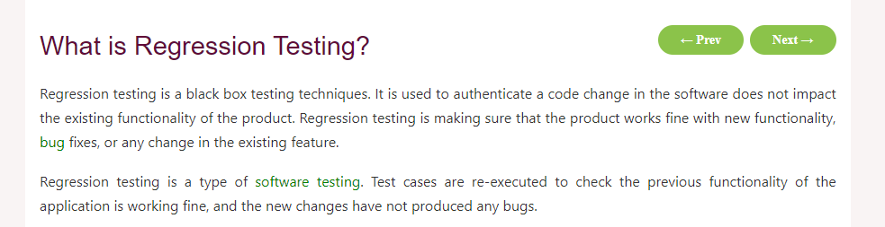

Smoke Testing

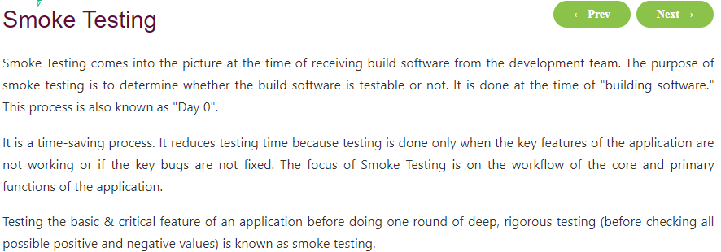

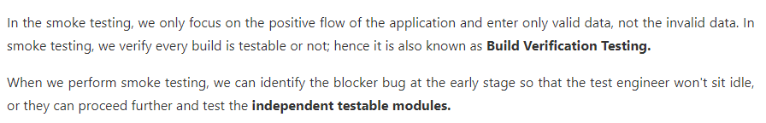

Sanity Testing

Generally, Sanity testing is performed on stable builds and it is also known as a variant of [regression testing](https://www.javatpoint.com/regression-testing).

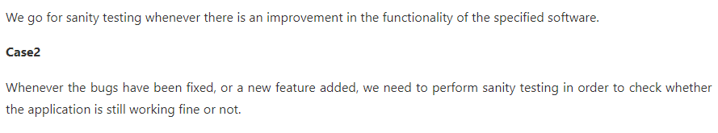

**Test Plan**:

A test plan is a document that outlines the scope, approach, resources, and schedule for testing a specific system or application.

It serves as a guide for the testing team throughout the testing process.

In the case of an e-commerce website like Amazon, a test plan might include sections on:

* objectives (e.g., ensuring smooth shopping experience, secure payment transactions),
* testing methodologies (e.g., functional testing, security testing),
* resources needed (e.g., testing environments, tools),
* and the schedule of testing activities.

**Test Strategy**:

A test strategy is a high-level document that defines the overall approach to testing. It outlines the goals, methods, and techniques to be used in testing a system or application. For an e-commerce website like Amazon, the test strategy might include approaches for testing various aspects such as user interface, functionality, performance, security, and compatibility across different devices and browsers. It may also include considerations for automation testing, regression testing, and user acceptance testing.

**Test Execution**: Test execution refers to the process of running test cases according to the test plan and strategy. It involves executing test scripts, observing the system's behavior, and comparing actual results against expected results. In the context of an e-commerce website like Amazon, test execution would involve activities such as adding products to the cart, processing payments, searching for items, navigating through different pages, and ensuring that all features work as intended across different scenarios and user inputs.

**Test Design**: Test design involves creating detailed test cases and test scenarios based on requirements, specifications, and user stories. It encompasses defining inputs, expected outputs, preconditions, and postconditions for each test case. In the case of an e-commerce website like Amazon, test design might involve creating test cases for various functionalities such as user registration, product search, adding items to the cart, applying discounts, checking out, and viewing order history. Each test case would specify steps to be performed and expected outcomes to be verified.